**Index.js**

Calling App.js

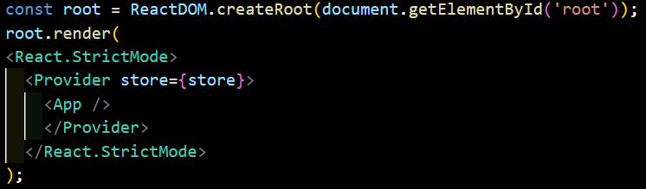

**App.js**

Calling Routetable.js

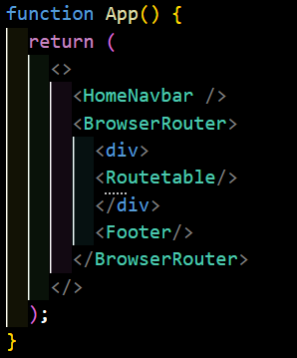

**Routetable.js**

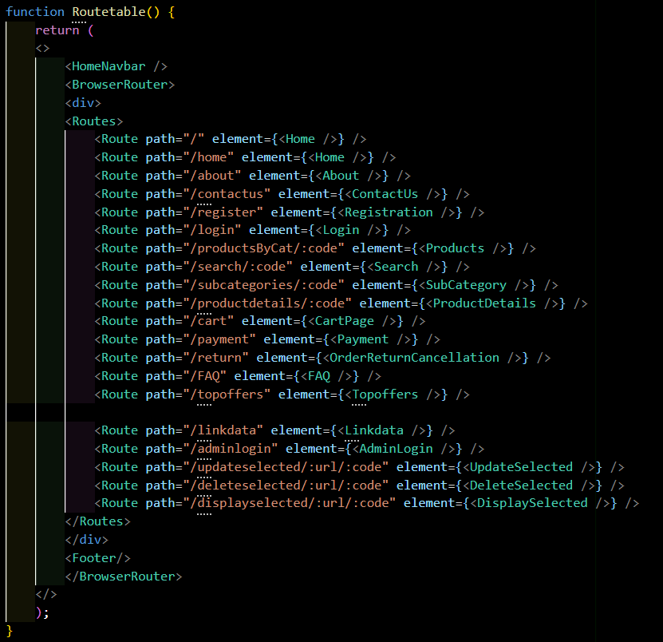

**Home.js**

Fetch link to get data from backend:

For **Categories**,

http://localhost:8081/api/Categories

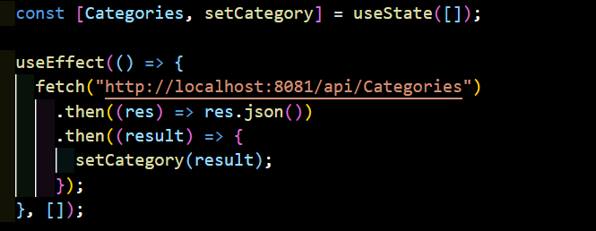

To render Categories on Home page,

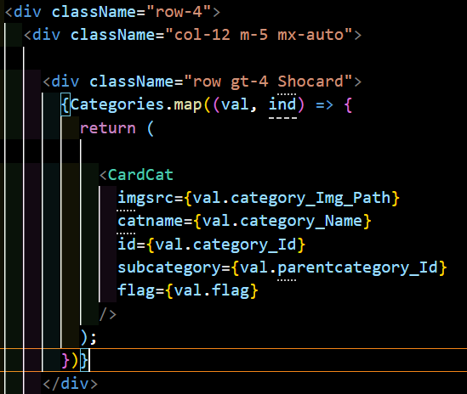

**INPUT:**

Taking Data dynamically from database using props

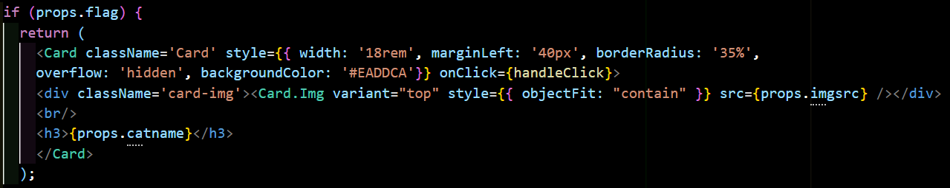

**OUTPUT:**

Shopping by Categories

